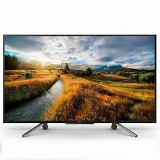

***Tcl 8k fully automatic led***

* **Color:**Black
* **Available:**in stock
* **Dimension:**1641*595*600
* **Size:**33
* **Old Price:**~~Rs 21,000~~
* **New Price:**Rs 17,000 (5%)